H-BRIDGE MOTOR DRIVER CIRCUIT:
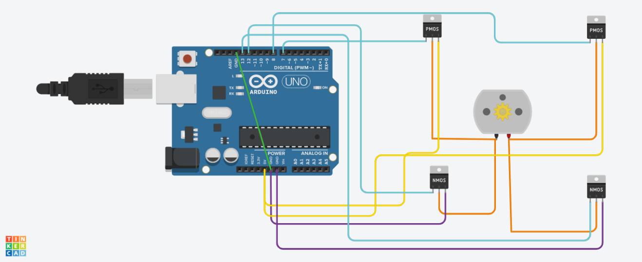
Circuit link:
https://www.tinkercad.com/things/dMSgwb62vcW-h-bridge-/editel?returnTo=%2Fdashboard%2Fdesigns%2Fcircuits&sharecode=mr1p-B3P3wwi9rfSk-MB2f8fBqo5lJ89nr3pGr65O8c

H-bridge motor:
It’s a type of motor that can change direction depending on the direction of current through it. To achieve that function a motor needs a driver circuit to operate it.
This circuit is basically 4 switches , by opening and closing two at a time the direction of the current can be controlled.
If we imagine there are 4 regular switched in the circuit above inplace of the mosfets; by closing the top left and bottom right the current flows through the motor from left to right resulting in rotation,if the top right and bottom left are closed the motor reverses that rotation.
Using the switches is inefficient and since It could lead to instances where the wrong swtches are still closed when changing the setting MOSFETS are typically used to limit error,preventing shortcircuits and loss of energy by turning off the circuit entirely.
MOSFETS:
Mosfets act as electronic switches , they switch on and off by only applying voltage to the gate making them easier to control with microcontrollers.they waste little power,can switch on and off very quickly and can handle high current and voltage which is more fitting for the motor compared to other BJTs.
P-MOSFETS:
The p- mosfets used in the arrangement are at the top left and right, each supplies the motor with supply voltage at a time. they are active low components meaning they operate when the gate voltage is less than the source voltage of their pins. At low pwn signal the difference between the gate and the source pins is negative since the source pin is connected to the supply.
n-mosfet:
the n-mosfets in the circuit are at the bottom left and right.each connects the motor to ground at a time and they are active high components meaning they operate when the gate pin voltage is greater than the source pin voltage.since the Arduino supplies the circuit with equal voltages in its voltage supply and maximum pwm voltage ; the n-mosfets’ source pins are connected to ground,so they turn on due to the difference in potential in case of high pwm signal.

